
Large Block Space Triangulation, a Rudimentary Explanation
July 2008

When Reference3D processing was begun in 2002, the practice involved loading 10 to 50 HRS stereo strips and accompanying HRG data into a computer environment and a five step iterative space triangulation calculation process was begun to remove all possible locational and bias errors between the various data components. When the calculation process was finished (some hours or days later) all the elevation data was extracted for each geocell in the block bundle and the geocells then went on to a finishing and QC process.

This initial process yielded an acceptable absolute error within the Ref3D specifications and without GCPs. That is:
Horizontal absolute—15 M CE90
Vertical--
Terrain slope 0 to 20 degrees 10 M LE90
Terrain slope 20 to 40 degrees 18 M LE90
Terrain slope greater than 40 degrees 30 M LE90

This processing capability got the program going but it had two major drawbacks:
1. Production was inflexible in that small regions were loaded in at once, a long computer calculation was run, and then all elevation posts would be extracted at once. This was particularly onerous if only a small subset of the geocells processed in that block bundle had been ordered by a customer. Once the server was shut down, or another project initiated, the space triangulation calculations disappeared.
2. The block bundles, while relatively large, did not permit the accuracy that simultaneous processing of larger areas would afford. The theoretical limit was determined to be about 6 meters CE90 absolute horizontal accuracy.

The advent of more powerful computer servers and lower-cost data storage enable SPOT and IGN Espace to establish a large computing environment in 2007 that enabled improved accuracy of products, and also lower production costs.

Block Computation

The very first large block bundle calculated was called the “Stan” named after the many …..stan countries of central Asia, that were covered by the block. A visualization of this block is shown below.

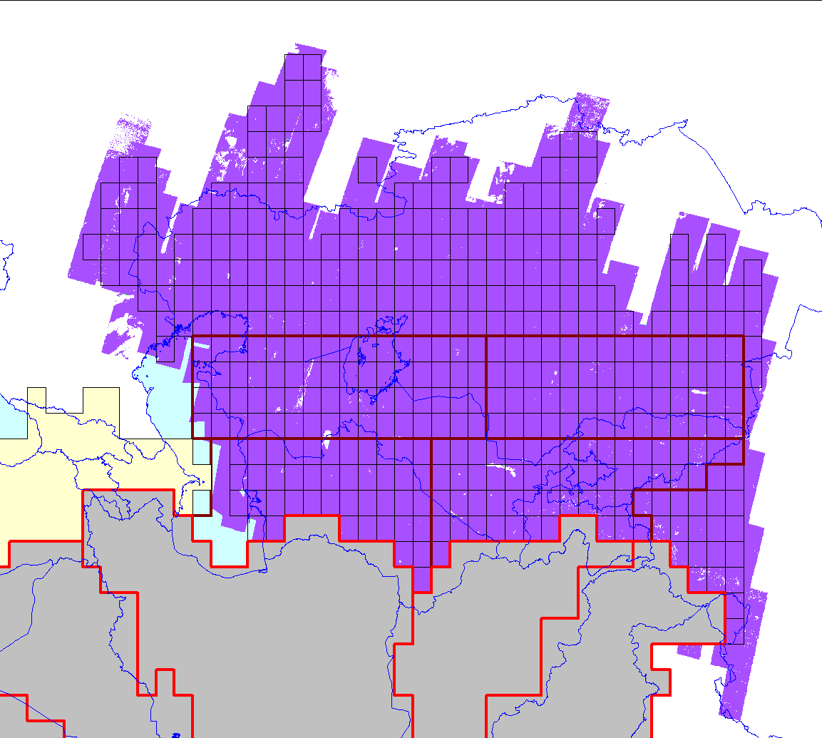

Figure 1. This is a view of the “Stan” Elementary Block (in purple) : 420 geocells, 4.5 M km²
The Stan block was the first such block assembled, and was the prototype for creating the other ~40 blocks required for world-wide coverage. Once the Stan Block was completed, the next Elementary Block to be assembled was over northern Africa. See the graphic below.

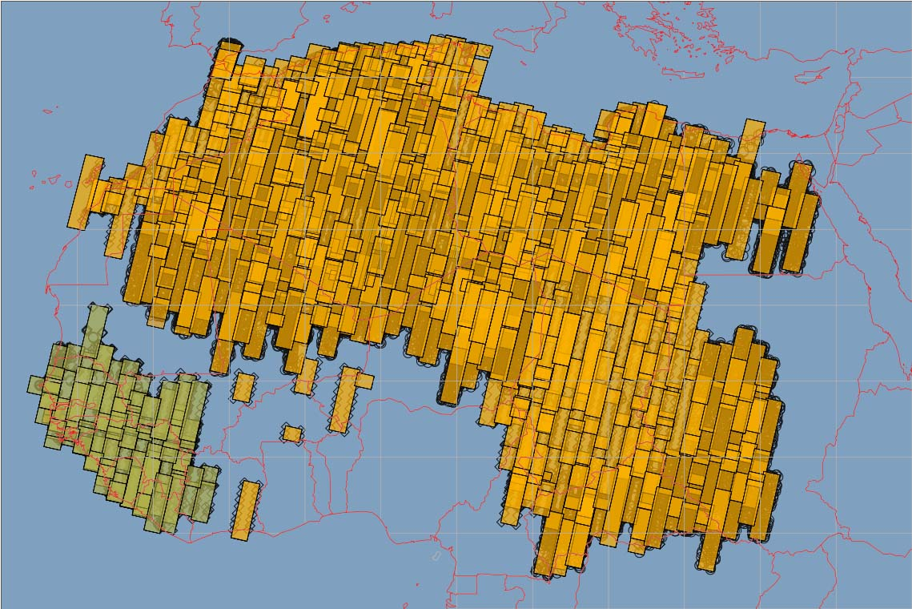
Figure 2. The northern Africa block is shown in a gold color, a smaller block to the southwest is shown in green. The small clear squares that appear at the edge of HRS stereo strips are tie points.

Here are some statistical comparisons between these first two project blocks.

Stan Northern Africa
HRS Pairs 270 600
HRG Image Strips 130 50
Geocells 420 252
KM2 Coverage 4,500,000 2,460,000
Stereo Pair Tie Points 26,000 54,000
Hours to calculate 12 60

The northern Africa block was created by merging several smaller surrounding blocks used in some of the earlier version one Reference3D production. Only a portion of the northern Africa block will be used in the production of the Algeria geocells.

One other interesting fact about the northern Africa block, the 60 hours of total computer calculation time was done in ten iterative calculations of 6 hours each. Each successive calculation period works the accuracy of the whole block down to a higher level. The process is repeated until the operators are satisfied with the end result, which we estimate to be an absolute accuracy of less than 10 M CE 90 horizontal and less than 10 M LE 90 vertically (in moderate sloping terrain). This should be compared to the original Reference3D production methodology using much smaller blocks, and only five calculation passes were performed. This points out one of the important enabling technologies of the large block project, the increase in digital data storage and computer calculating power relative to cost. This has been a remarkable trend from 2002, when the first Reference3D products were produced, until now.

The next two blocks that were calculated are over Australia and India. Here are some sample graphics of the areas that these two blocks now cover.

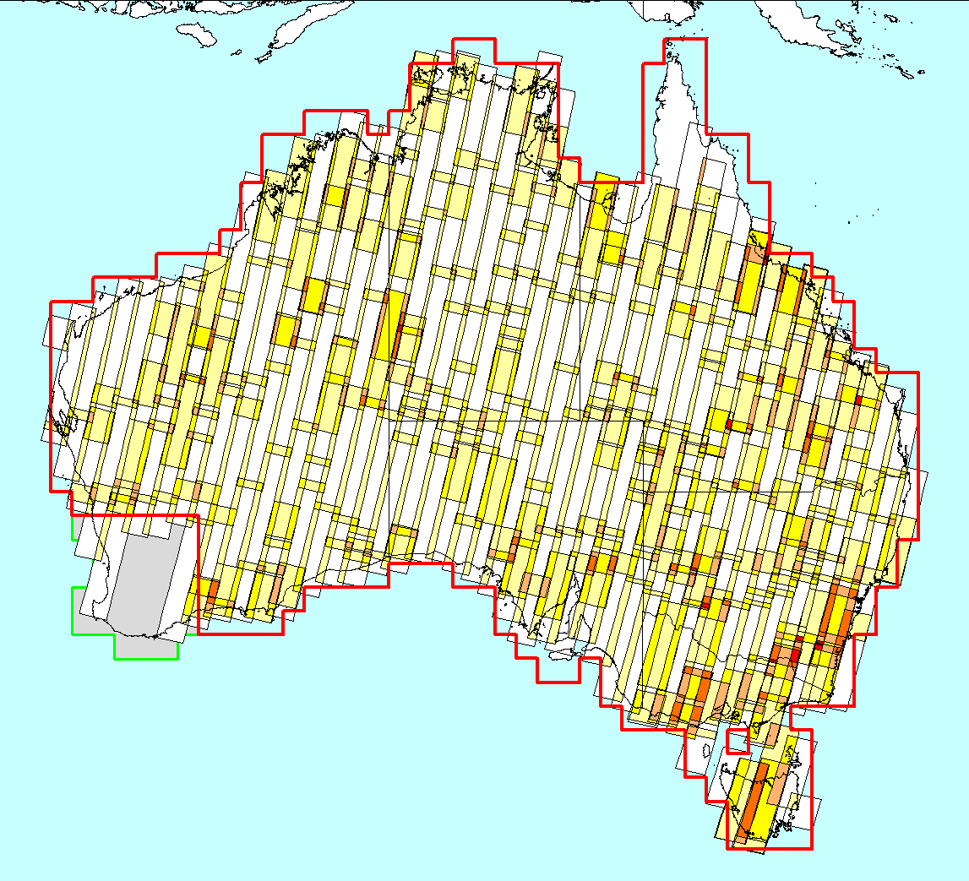
Figure 3. Outline of the Australia block.

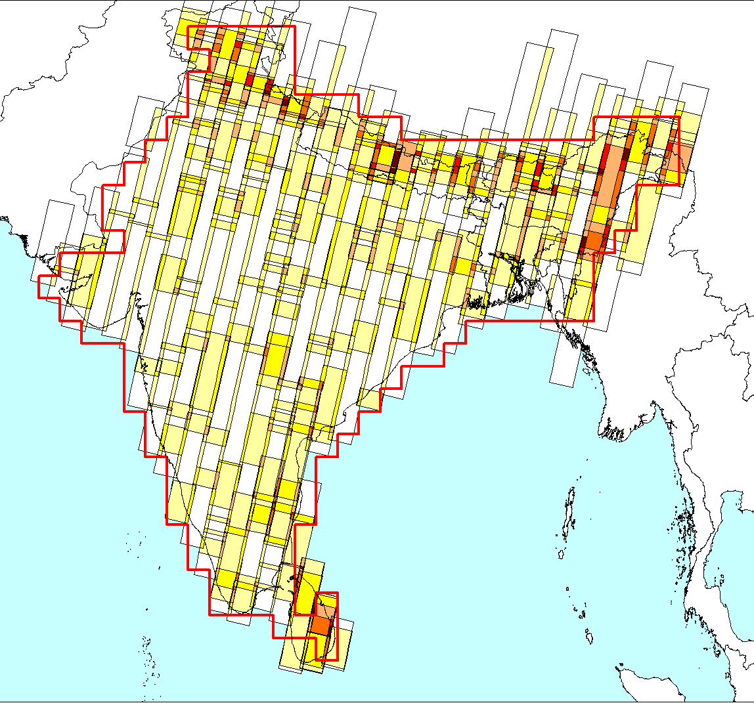
Figure 4. Outline of the India block.

Some preliminary statistics:

Australia India
KM2 Area 8,029,024 4,057,608
HRS Segments 734 727
Geocells 717 358

As of this writing, many other blocks have since been loaded into the system.

All this data is now kept in a “warm computing environment” so that small isolated blocks of geocells can be extracted as needed to fulfil customer orders.

END OF UPDATE

